
Stellingwerf Consulting
Complex Systems Analysis
Huntsville, AL

SPHC
Smooth Particle Hydrodynamics Code

Wind-Tunnel Modeling Capability

7/01/2010

R. F. Stellingwerf

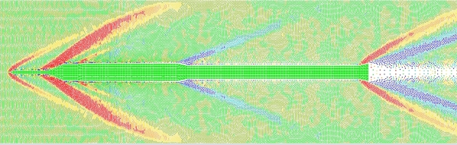
Long rocket body flow field, colored on radial velocity. See page 9.

STELLINGWERF CONSULTING
11033 Mathis Mountain Rd SE, Huntsville, AL 35803
    - rfs@stellingwerf.com
©2010 Stellingwerf Consulting

Blank page
Table of Contents

1 INTRODUCTION 4
2 Standard Wind Tunnel 7
2.1 Inflow Boundary 7
2.2 Outflow Boundary 8
3 Force Tracking 10
4 Variable Flow 12
4.1 Example – High Speed Wedge 13
4.2 Synching Inflow and Outflow Boundaries, Region Tracking 17
5 Piston Impact Modeling 17
6 Issues in Wind Tunnel Simulations 19
6.1 Subsonic Flow 19
6.2 Flow Delay Effects 19
6.3 Effects of Embedded Objects 19
7 Jet and Flow Sources 20
7.1 Kelvin Helmholtz Flow Instability 20
7.2 Debris in a Flow Field 21
8 Conclusion 23

INTRODUCTION

This memo describes the collection of techniques that have evolved within the hydrocode SPHC to enable the modeling of wind tunnel problems. Smooth Particle Hydrodynamics is a natural approach for this type of problem that could involve fluid flow, shocks, turbulence, and possible impacts. To do this we need a reliable method of fluid injection and fluid exit that works for both subsonic and supersonic flow. This is a challenge. Also, some attention to the side boundaries of the tube is needed to achieve reasonable results without modeling a huge volume. Finally, some option that models the impact of objects within the tunnel with a moving object or wall is needed to evaluate impact forces and pressures. These techniques have been developed, and are described below.

Before embarking on the wind tunnel approach, we should mention that it is actually quite easy to model the motion of an object through a fluid with SPHC, and in some cases this is a very reasonable approach. An example of this approach is shown below.

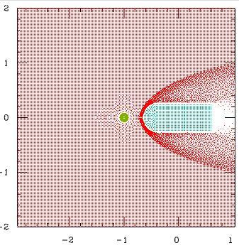
A box has been set up containing gas, and a projectile travels in from the right to the left. The box has reflecting boundaries (all four sides) to contain the gas, and these can be set to act only on the gas, so the projectile can be initialized outside of the gas, and allowed to move in. The image shows the situation after a shock has formed in front of the projectile. In this case a water drop has been placed in the path of the bullet, and the resulting impact can be modeled.

Boundaries for this type of problem are set as follows:

set_boundary right
direction y // x is default
location = Tube_len/2 // 0 is default
side high // low is default
type reflect // default
end_boundary

where Tube_len is the length of the gas region, and the origin is in the center at time 0 (the initial run-in is not shown in the figures). These cylindrically symmetric cases have the “Y” axis displayed horizontally, the “X” axis vertically. The items marked “default” could be omitted, but are usually specified for clarity.

The gas region is defined as follows:

begin_region "tube"
part_mult = Vtube/Vtot
do_block Tube_wid Tube_len Tube_wid

Here Vtube and Vtot represent the volumes of the tube (gas) area and the total volume.

The “rod” (projectile) is a bit more complicated:

begin_region "rod"
part_mult = Vrod/Vtot
do_block Rod_wid Rod_len Rod_wid
translate_reg 0 -Rod_len+Rod_wid/2+Tube_len/2 0
part_mult 0.25*pi*Rod_wid^2/Vtot
set_no_neg 0 1 0
do_sphere Rod_wid/2
reflect_reg 0 1 0
translate_reg 0 Tube_len/2-Rod_len 0
merge_sub_regions
set_no_neg 0 0 0
make_room_reg 3
velocity_reg 0 -Rod_vel 0

In this case the “translate” commands are used to position the rod, the “set_no_neg” commands are used to create a ½ sphere end to the rod, and the “make_room” commands are used to drop overlapping gas particles that have been created in the previous step. Note that the make_room command must always come after the adjustments and positioning have been applied. Finally, a velocity is applied to the rod.

This should give some flavor of how objects and regions are created in SPHC. This in turn should provide a basis for comparison with the more complicated wind tunnel commands described below.

Here is an example of the subsequent stages of a similar model with a more water drops, colored on density.

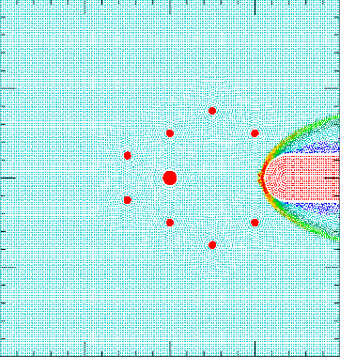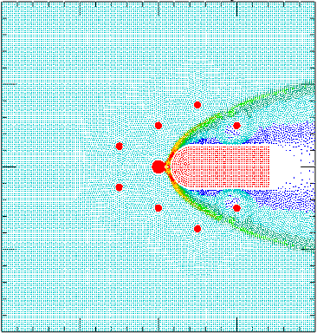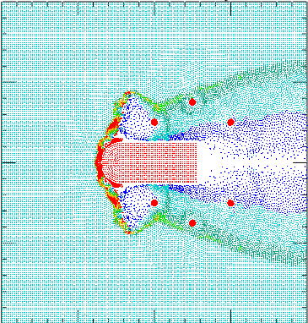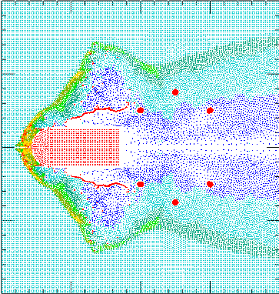

The overall structure of the shock, drop impacts, and the effects of the drop impacts on the flow are modeled well. The details of the effect of the shock and post shock flow on the drops are not apparent, however, primarily because of the lack of definition in the drops. One way to focus on the drop effects is to model a single drop in the flow field created by a moving object. This is the wind tunnel model.

Standard Wind Tunnel

The standard treatment shown in the previous section has the disadvantage that only flow patterns and structures that develop during the transit of the gas cell can be modeled. For more complicated cases, longer time scales, and better definition of the impactors (water drops in the previous illustration), a wind tunnel simulator is needed. The initial setup for a wind tunnel model is similar to the static cell case, but the projectile, if any, is placed near the center of the cell, and the gas in the cell is in motion, rather than the object in the flow. To accomplish this special boundaries are needed at the left and at the right sides of the cell.

Inflow Boundary

The example is that of a dart in a Mach 18 flow field, standard atmosphere. The setup looks like this:

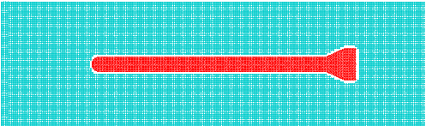

The boundaries on the gas cell are unchanged on the top and bottom, but the boundary on the left is modified to provide a constant flow of new particles into the problem. This is done by moving the left boundary as a piston, but when the boundary traverses a preset distance (called the buffer_width, shown as a dashed line), it is recycled to the left and a new layer of particles are inserted between the old and new positions of the boundary. The setup looks like this:

#---inflow boundary---
set_boundary inflow
direction y
location = -Length/2-Inflow_length
side low
velocity = Flow_velocity
buffer_width = Inflow_length
end_boundary

The “Y” direction is horizontal in this plot. The buffer_width parameter can be adjusted to provide an adequate number of recycling cycles for the given run. The name “inflow” for the boundary signals that this is a special case, and this name cannot be used for an ordinary boundary anywhere in the problem. Only a single inflow boundary can be specified in the present version of the code.

The inflow buffer is specified just as any other region, but must be named “inflow”. The conditions in the buffer usually match those of the remainder of the wind tunnel, but could vary. This would be the case if an initial shock moving into the tunnel was desired.

set_region inflow // inflow region
material pg
eos pg
gamma = 1.4
mu = 29.
density = Density
temp = Temp
end_region

More details on the inflow boundary will be given in the “Jet and Inflow” section below.

Outflow Boundary

On the right side of the problem particles must be removed as they exit the gas cell. For a supersonic case such as this one, a simple absorb boundary may be adequate:

#---outflow at right---
set_boundary out
direction y
location = Length/2
side high
type = absorb
end_boundary

Better results are usually obtained, however, by using an outflow version of the inflow boundary described above:

#---outflow at right---
set_boundary outflow
direction y
location = Length/2
side high
type = reflect2
buffer_width = Inflow_length
velocity = Flow_velocity
drift_velocity = Flow_velocity/8 // allow drift
end_boundary

The boundary name “outflow” indicates a recirculating boundary.

Note that the type is “reflect2” rather than the default value of “reflect”. This means that when the boundary recycles, any particles finding themselves on the wrong side are automatically dropped. This type of boundary is also useful for delayed boundaries.

An additional option used here on the outflow boundary is a “drift” velocity to gradually move the outflow boundary to the right to allow the flow to develop or allow for the movement of the object in the flow.

The evolution of this model is shown below, colored on density.

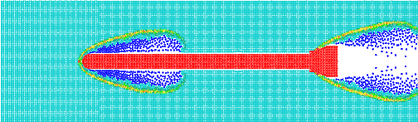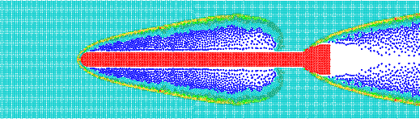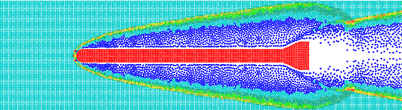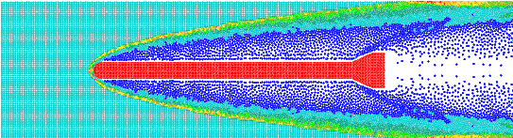

Note the drift of the outflow boundary at the right. The flow model can be run as long as needed to obtain the final flow pattern. The figure on the cover of this report shows a similar tunnel test, but using an approximate Ares I outer mold line for the dart, and a flow velocity of Mach 2, colored on radial velocity. In this case the flow field is computed covering a distance of over 400 ft.

The upper and lower walls in this model are “reflect” boundaries. For lower speed flow this would produce reflected waves from the side walls. To reduce this effect the option type = soft_reflect can be used. Soft_reflect boundaries are identical to reflect boundaries (particles see a refection of themselves and their neighbors), but the velocities of the reflected boundary particles (sometimes called “ghost particles”) are not reflected, as in the usual “reflect” boundary, so a flow condition across the boundary is approximated. This allows some flow through the boundary in higher pressure regions while containing the flow in undisturbed regions.

The dart in a wind tunnel simulation of this type can either be “frozen” (as set in the region definition), or left to move in the flow. In the case shown the dart was frozen. If allowed to move, both the inflow and outflow boundaries can be set to drift, or see “CoM Locking”, below. Frozen regions do not respond to exterior forces, but could have a specified constant or time dependent velocity, thus acting as a piston.

Force Tracking

The force on an object in the flow or on a boundary can be tracked in the history dump. For a boundary the force is always perpendicular to the surface and a single entry is made to the dump file. For a region (usually a frozen region, but not always), the total force as well as its components are dumped. This allows the lift and drag to be monitored as a function of time. The force is computed by summing the pressure gradients for all particles adjacent to the region or boundary at each time step.

The command, which is inserted either in a region block or in a boundary block, is:

track_force {zdepth {mult {source_reg #}}}
(write total external force on a region to history file. For 2D, specify zdepth = “out-of-plane” thickness, default = 1 cm) (mult = optional multiplier) (third arg – force from one region only)

Just “track_force” usually works. The arguments are useful in special cases. For example, if symmetries are used, the correct total force can be output by setting the multiplier to 2 or 4, depending on the number of symmetry planes. Units are set with the command

set_units bdry_force lbf Lbf

Here the “lbf” is the label which will be appended to the force label, and the “Lbf” is the conversion factor to cgs units, which must be defined. e.g Lbf = 4.4482e5.

As an example, the region block of an airfoil run is:

set_region wing
material al
eos grun
frozen
track_force
end_region

The model build block is:

set_no_neg 1 0 0
begin_region wing
part_mult = 2*Vwing/Vtot
do_sphere Rad // top of circle
skew_reg 0 -1 // airfoil, at 45 degrees
rotate_reg 0 0 -40 // move near horizontal
set_no_neg 0 0 0

When embedded in a standard wind tunnel, this setup looks like:

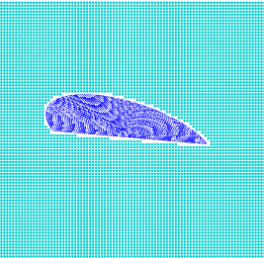

In a 2,000 ft/s flow field, colored on density, the model evolves as follows (2.5 ms intervals):
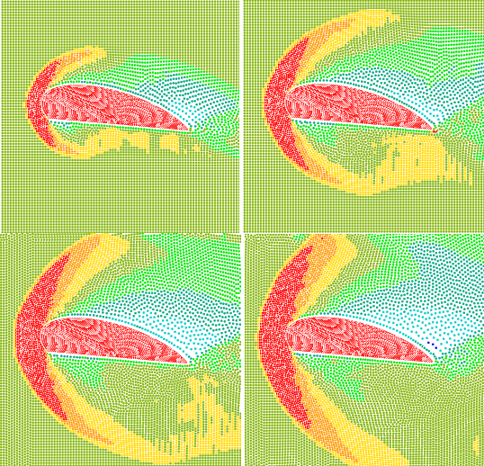

A shock forms in front of the wing in this supersonic case. A turbulent region is just beginning to form at the back edge. The blue low density, and hence low pressure, region above the wing provides the lift.

The force on the wing versus time is shown in the history plot below, where the dark blue line is the X component of the force (in this case X is vertical, so this represents the lift force), and the light blue line is the Y component, or drag force (smoothed curves). In this case the lift is positive, but smaller than the drag. The units on this 2D simulation are lb force for a 1 cm section of the wing (this length can be specified in the track_force command).

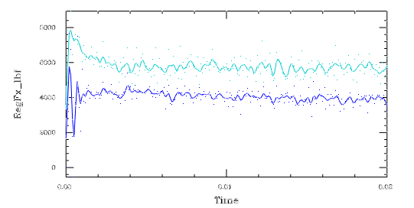

Variable Flow

The inflow conditions at an inflow boundary can be varied with time. To set the parameters of the inflowing gas as a function of time, an additional block of commands are added to the setup file.

set_inflow_vars
ipoint time1 velocity1 density1 temp1 [angle]
ipoint time2 velocity2 density2 temp2 [angle]
------
------
end_inflow_vars

Each “ipoint” line takes either four or five arguments, the last – angle – being optional. The first time is normally 0, the units are cgs, with the temperature in degrees K. The angle specifies the angle of the flow in degrees, 0 being along the Y axis, increasing clockwise ( atan2( Vx, Vy) ). During the calculation the conditions will be linearly interpolated between the specified points. After the last point the last value will continue to be used.

A convenient method of specifying a complex time variation is to set the values in a external data file. Using a comma separated text file with single first line containing labels or file description, the coding would be:

$file = input_file_name // set data file here
set_delim comma // for .csv format
read_line $file $label_line // read title
set_inflow_vars
for_i = 1 1000
read_line $file X1 X2 X3 X4 [X5]
break_if eof
ipoint X1 X2 X3 X4 [X5]
end_i
end_inflow_vars

The flow field characterization can be obtained from an SPHC model, such as the example shown in Section 1, or from a CFD solution for a given flow. See the “Issues” section below for adjustment sometimes needed in the input flow to achieve a more accurate flow in the vicinity of a water drop or other object in the wind tunnel model.

Example – High Speed Wedge

An example of a complex flow field is that of a wedge. The figures below show the angle and magnitude of the velocity in the vicinity of a 10 degree wedge at 20,243 ft/s.

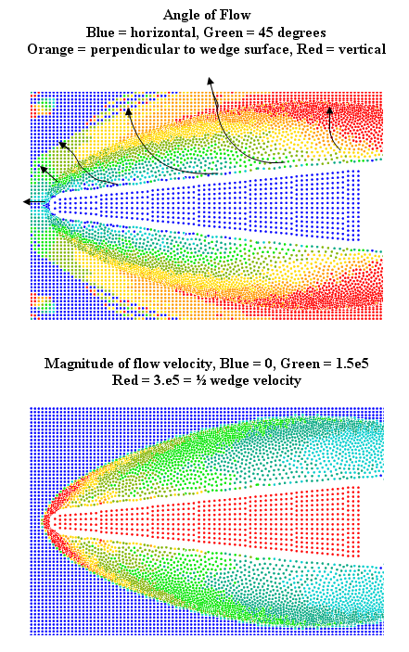

Now imagine a water drop in the vicinity of the wedge as it approaches. The drop will see rapid increase in local flow velocity at the shock followed by a rapidly varying flow field, both in magnitude and direction as it approaches the wedge. Large variations in temperature and density will also be experienced by the drop. It would be possible to insert one or more drops in this simulation, as described above, but the resolution in the drops would be low. A typical simulation result of this sort (22.5 degree wedge at 4,200 ft/s) is shown below.

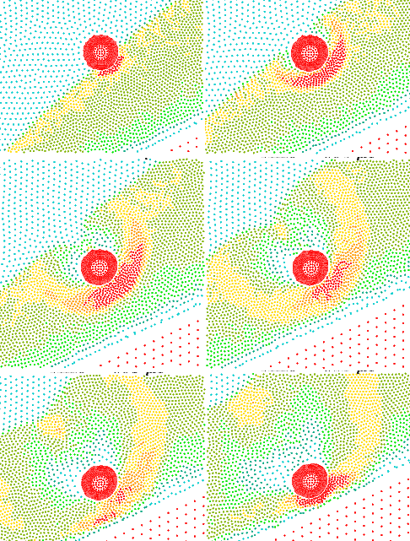

In the upper right panel the flow field is nearly perpendicular to the wedge surface. In the lower left panel, however, the flow has shifted more from the right, reflecting the surface flow effects. The shape of the drop is responding to this changing scenario, but the resolution in the drop is too low to catch the fleeting effects.

Now consider the same case, but using a time-varying wind tunnel simulation. To do this we need to determine the time variation of the flow at the drop location. Rerun the drop model without the drop, but with a probe at the drop location. The resulting variations of flow velocity, temperature, density, and flow angle are shown below.

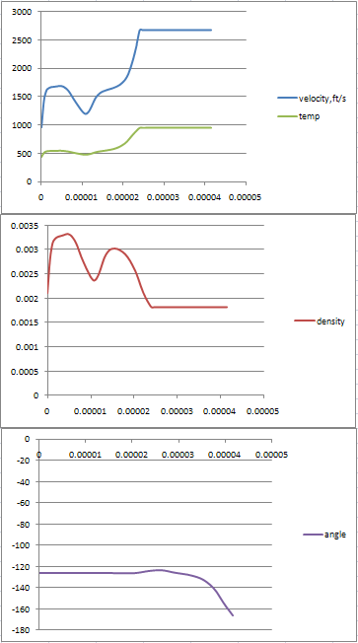

These data are stored in an external file, and then read into the setup via an “ipoint” command in a loop, as shown earlier. Trial runs should be done with low resolution and probes to test for flow delays and any flow disruption effects of the drop. See the “Issues” section for more details and suggestions.
The figure below shows the wind tunnel model of this case at a time corresponding to the lower left panel in the drop run. This plot was made with the plotter Thor. Thor has been modified to automatically rotate the axes to the angle corresponding to the flow angle being used at each plot file time.
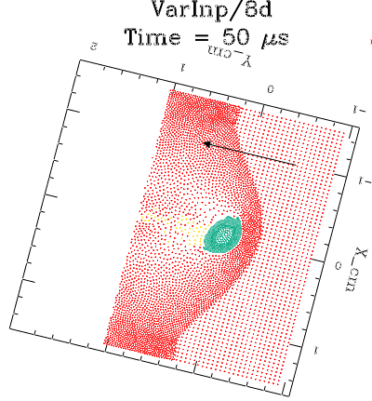

The figure below shows a close up of the drop just as it is about to impact the wedge. The details are now apparent and the shape is much better resolved. The actual modeling of the impact will be discussed in Section 5, below.

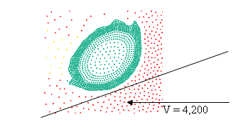
V(perp) = 1,607 ft/s

The wind tunnel approach is also useful for cases requiring 3D modeling, since a greater resolution is essential in this case.

Synching Inflow and Outflow Boundaries, Region Tracking

The command

synch_boundaries

causes the outflow boundary velocity and drift values to be equal to the inflow values at that time. This command is placed outside of any boundary or region block.

It is also possible to synchronize both boundaries to the movement of an object in the flow. This is useful in the case of a water drop or item or debris caught in the flow, whose shape and trajectory are of interest. The command is a variation of the drift velocity command placed in the inflow boundary definition block:

drift_velocity reg {region_number}
e.g.
drift_velocity reg 3

In this case the inflow and outflow boundaries will be synched, and both of their drift velocities will be adjusted to the current velocity of the center of mass of the region specified. This should keep the object centered in the simulation, even if it moves in a non-linear or erratic fashion. Care should be taken to make the flow region wide enough to allow some sideward drift, since this direction is not adjusted by this command.

Test 8d, shown above, used a center of mass lock on the drop. At the conclusion of the calculation the drop velocity is over 100 ft/s. Although this drop only moves about 0.2 cm in the course of this simulation, drops have been tracked through over 50 ft of flow using this technique in the Ares flow field shown on the cover.

Piston Impact Modeling

The command to terminate the inflow recycling and convert the inflow condition to a simple piston is

free_time # {vel}

This command should be placed in the inflow boundary block. The first argument is the time of conversion. The optional second argument specifies the velocity of the piston. Default is the current velocity of the inflow boundary.

As an example, the model VarInp/8d shown above was rerun with the command

free_time 30*Usec 1607*Ftps

inserted in the inflow boundary block. The velocity is the wedge velocity (4,200 ft/s) multiplied by the sine of the wedge angle (22.5 degrees). Care should be taken to obtain a flow angle equal to the impact surface angle at or just before the free-time specified.
Shown below: 4 μs intervals starting just before piston impact.

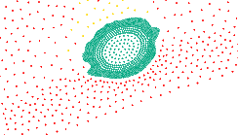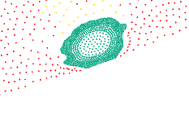

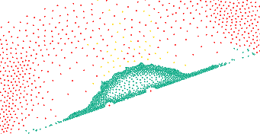

This is the force on the impacting piston boundary.

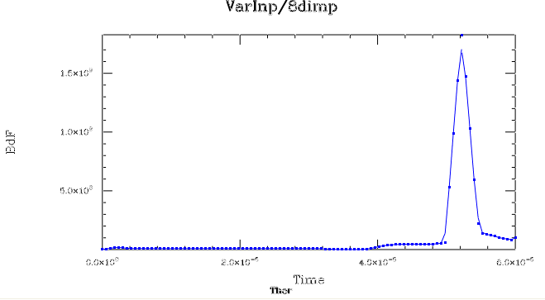

Issues in Wind Tunnel Simulations

Subsonic Flow

The present approach to the wind tunnel model is designed to handle either subsonic or supersonic flow. In the subsonic case, however, special care needs to be observed, since disturbances caused by objects in the flow field will propagate back to the incoming gas. Usually, placing the inflow boundary sufficiently far from the flow constrictions can resolve this problem. The presence of a problem will appear as a series of waves generated by the inflow region each time the boundary recirculates, indicating that the boundary is too close to the disturbance. It may also be possible in some cases to approximate the upstream effects by gradually varying the conditions in the inflow region to better match the final flow solution near the inflow boundary.

Flow Delay Effects

In the case of time varying inflow conditions, the delay time between the inflow conditions and the variation of the conditions at the location of the object of study needs to be considered. Also, in the case of synchronized boundaries, some dwell time will be needed for the inflow conditions to “catch up” with the changes in the outflow boundary. For supersonic cases if this is a problem, a simple “absorb” outflow boundary may be beneficial. For subsonic cases the solution to boundary problems is usually to move the boundaries further away from the region of interest and allow extra time for the flow to stabilize.

Effects of Embedded Objects

An object in the wind tunnel will affect the flow parameters in its vicinity. For steady flow problems this usually means extra computation time to allow for the flow to settle down. For time dependent problems, it is sometimes possible to “kick” the initial flow a bit by increasing the velocity and/or density to achieve the desired velocity field, then gradually settling down to the final flow parameters. Inserting probes in the vicinity of the embedded object can be used to monitor the actual time dependent flow field at any point in the flow. Some experimentation is required. Moving the side boundaries away from any embedded objects will help if possible, or changing the side boundaries from “reflect” to “soft_reflect” could be of benefit.

Jet and Flow Sources

Kelvin Helmholtz Flow Instability

The Kelvin Helmholtz instability occurs when gas is rapidly moving across the surface of a liquid. In the following test case the movement of the gas is tilted toward a water region that has an initial perturbation on the surface to accelerate the formation of surface waves. The initial setup looks like this:

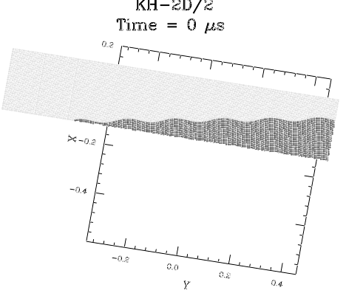
g
The inflow boundary is at the left, and is parallel to the Y axis. The gravitational force is tilted, as is the surface of the water region (darker, at bottom). Gas velocity is Mach 1. The outflow boundary at the right allows gas, but not water to exit the model. Growth of the instability is shown below.

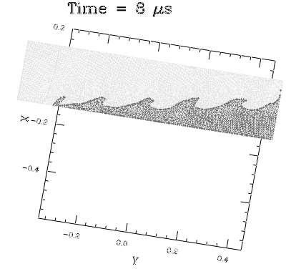

Debris in a Flow Field

The figure below shows a model of a generic linear shaped charge (dark blue) poised to cut through a notched aluminum plate (aqua blue). The orange and yellow regions are support structures. The red block is an inflow region modeling a plume of hot gas representing a maneuvering thruster rocket. The purpose of the model is to study the interaction between the debris generated by the LSC and the plume.

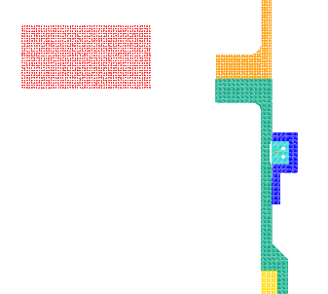
This is the code for the inflow boundary:

set_boundary inflow
location Atm_top
direction y
side high
velocity -Atm_veloc
region Atm_reg
buffer_width Atm_len
end_boundary

Boundaries are placed at the right and left edges of the gas slug:

set_boundary A_lft
location Atm_left
direction x
limit y 1.8*In 200*In // nozzle
side low
region Atm_reg
end_boundary

set_boundary A_rt
location Atm_right
direction x
limit y 1.8*In 200*In // nozzle
side high
region Atm_reg
end_boundary

This is the code for the inflow region, note the skewed velocity:

#---atmosphere slug---

begin_region inflow
set_h = 3*Smln0
do_block Atm_width Atm_len 0
translate_reg (Atm_left+Atm_right)/2 (Atm_top+Atm_bot)/2 0
velocity_reg -Atm_veloc*sin(Atm_angle) -Atm_veloc 0

This shows the evolution of the model:
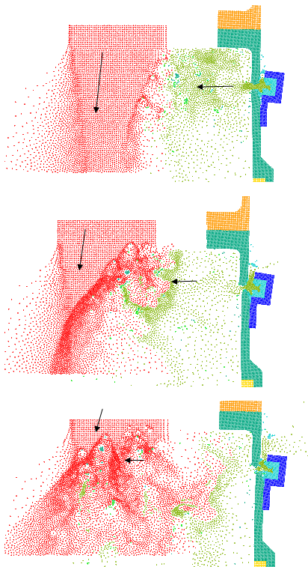

Conclusion

This memo documents and illustrates the wind tunnel capability of the SPHC code as of version 10.20. The various options, applications, and variations are shown, as well as a sampling of the type of cases that have been recently run with the code. Sample code fragments are shown to illustrate problem setup. For more details, visit the web site www.stellingwerf.com. Licensed users of SPHC can obtain input files for any of the examples shown here on request.

